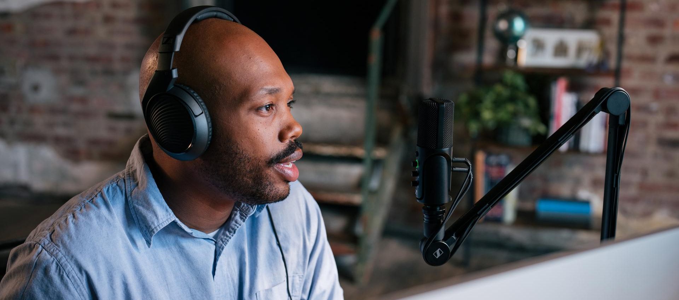

Sennheiser’s top podcast gear picks
Celebrating this year’s International Podcast Day, Sennheiser suggests some of its top audio solutions to suit any situation and any budget

Wedemark, 5 September 2023 – For the past nine years, September 30th has been deemed International Podcast Day. This global celebration of the power of podcasts has become a firm favourite with those who listen to them and those who create them – and there’s so much to choose from, with something for everyone, from true crime, conspiracy theories and celebrity feuds, to health, wealth and happiness.

For the creators of these tantalising stories and interesting insights, apart from great content, one thing is vital – good audio. So, whether you’re planning on dipping your toe in the podcasting sphere and want a budget solution, or you’re an experienced podcaster who wants a serious upgrade for your audio equipment, Sennheiser has got just the right solution for you.

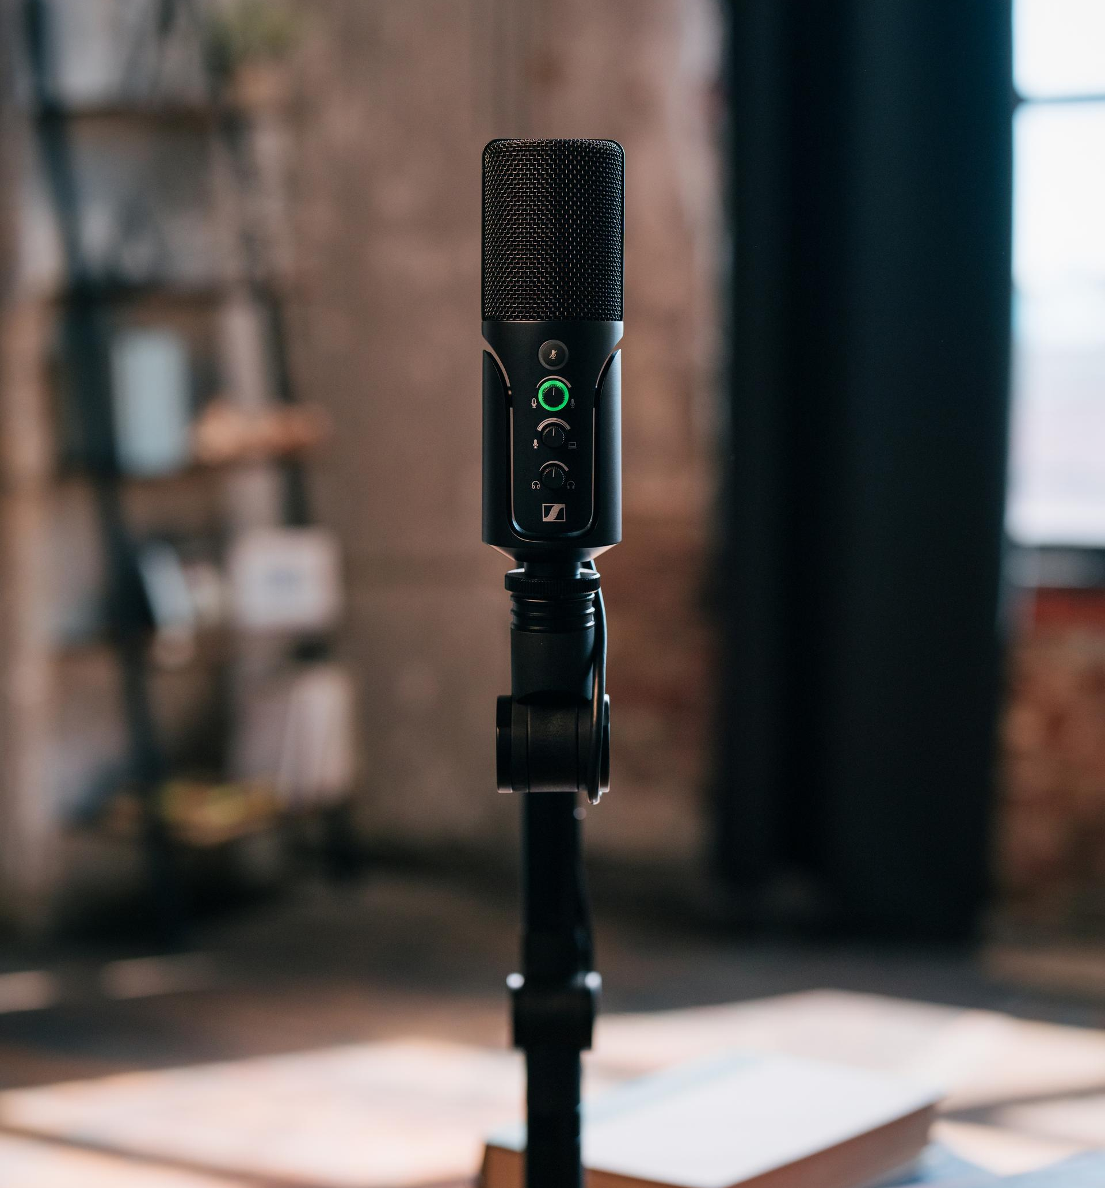 | Created for podcasting and streaming applications, the Profile USB microphone is where performance meets accessibility

If you’re just getting started and you are doing a single-person podcast either at home or in a studio, we think the Profile USB is the perfect microphone, as it simply plugs into your desktop or laptop computer, and you’re ready to go. If you’re inviting your friends to be part of things, the e 835 with a Zoom recorder is ideal. Pair either option with HD 200 PRO headphones for monitoring, and you’ve got a great setup. If you want to do your podcast on the move on your mobile phone, an XS Lav USB-C Mobile Kit is just what you need.

A professional-quality cardioid condenser microphone for home, project, and professional studios, the large-diaphragm MK 4 produces powerful warm sound | 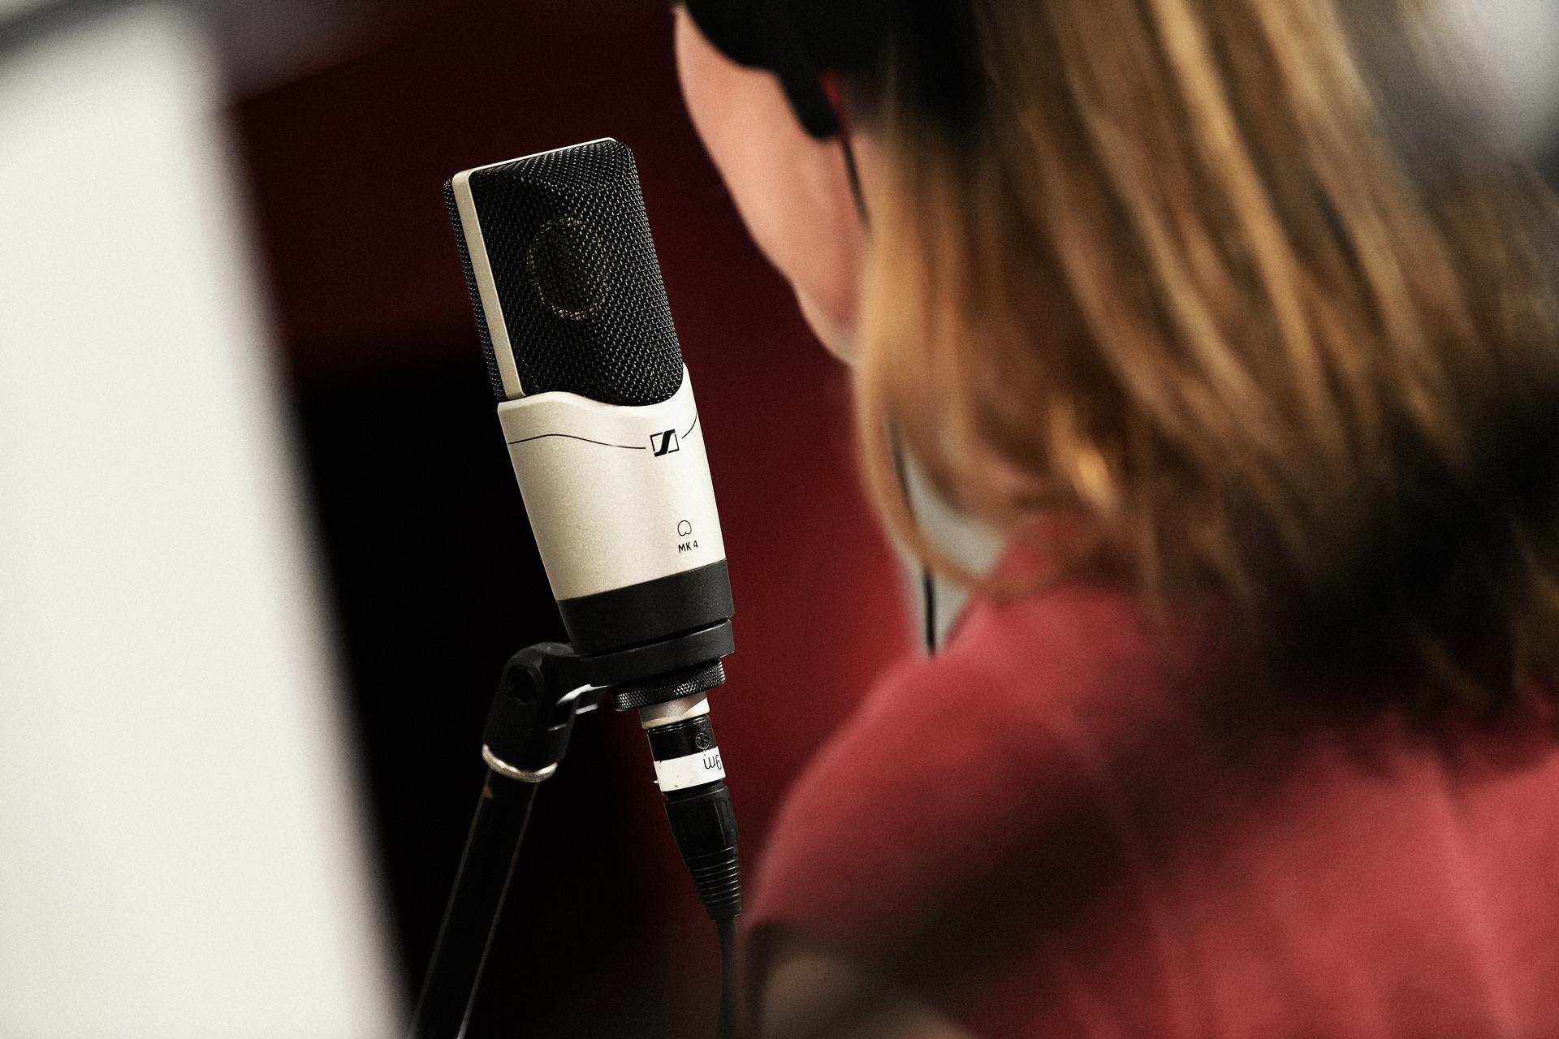

If you’re thinking of investing a little more, for indoor podcasts, the MK 4 studio microphone is perfect, and for picking up sound out of shot, choose the MKE 600. Then just add a pair of HD 280 PRO for monitoring. Outdoors or on the move, for either a mobile phone or DSLR camera, either the MKE 200 or MKE 400 coupled with our HD 25 Light will serve you well.

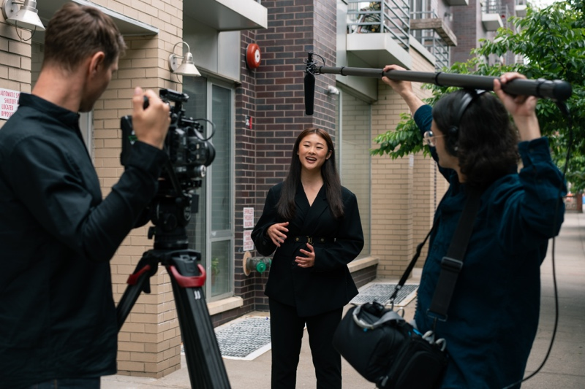 | For the seasoned professional, Sennheiser recommends either the MKH 416 or MKH 8060 as a great wired microphone to go with your pro camera setup

For those who’re moving towards podcasting pro status, think about investing in an MK 8 studio mic, with an MKH 416 or MKH 8060 for out of shot sound and the HD 300 PRO for monitoring. Outdoors or on the move, we’d choose the MKE 600 as a DSLR wired solution and the AVX if you want to go wireless and add the ever-popular HD 25 as your monitor option.

And for the seasoned professional, we’d recommend either the MKH 416 or MKH 8060 as a great wired microphone to go with your pro camera setup, or the new EW-DP if you want the ultimate wireless solution paired with HD 25 PLUS headphones. And for professional multi-person podcasts, the MK 4, MD 421 or MD 441 microphones with a Zoom recorder or high-end interface and either of these great headphones will work a treat.

Used by professionals the world over, Evolution Wireless operates in the UHF band and is known for its reliability, flexibility, and comprehensive feature set. Whether you’re a crew of one or many, EW-DP is the ideal partner to simplify your audio workflow | 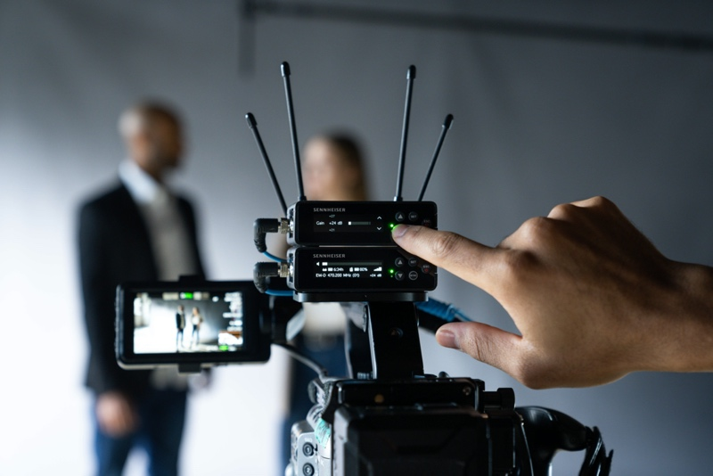

Whatever you decide to choose, we wish you a very happy International Podcast Day.

(Ends)

The high-resolution images accompanying this media release and additional photos can be downloaded here.

About the Sennheiser Group
Building the future of audio and creating unique sound experiences for our customers - this is the aspiration that unites the employees of the Sennheiser Group worldwide. The independent family-owned company Sennheiser was founded in 1945. Today, it is managed in the third generation by Dr. Andreas Sennheiser and Daniel Sennheiser, and is one of the leading manufacturers in the field of professional audio technology.
sennheiser.com | neumann.com | dear-reality.com | merging.com

Global Pro Audio Press Contact
Stephanie Schmidt
stephanie.schmidt@sennheiser.com
+49 (5130) 600 – 1275

